
REGISTRY/ HOJA DE REGISTRO

NAME/NOMBRE COMPLETO | NATIONALITY/NACIONALIDAD: | AGE/ EDAD:
OCUPATION/OCUPACION: | COMPANY/NOMBRE DE EMPRESA O PARTICULAR: | E-MAIL:
PHONE/TELEFONO CONTACTO | WHATS UP? SI NO | ARRIVAL DATE:  DIA DE LLEGADA:
PAYMENT/FORMA DE PAGO: (CIRCLE, PONER CIRCULO)  PAYPAL, CASH, WESTERN UNION, DEPOSITO BANCARIO, OTRO | HOW DID YOU HEARD ABOUT THE WORKSHOP?  COMO TE ENTERASTE DEL CURSO?: | NECESITA HOSPEDAJE? SI NO  DO YOU NEED HOTEL/PLACE TO STAY? YES NO
SPACE IS LIMITED CUPOS LIMITADOS
Includes: Materials* equipment * breakfast *,drinks. certificate.
Incluye: * MATERIALES DE TRABAJO * EQUIPO DE TRABAJO * DESAYUNO * BEBIDAS * DIPLOMA
TO SAVE YOUR SPOT, PLEASE SEND REGISTRATION FORM ALONG WITH PAYMENT VERIFICATION TO: OCEANIKALIVING@GMAIL.COM
PARA GUARDAR EL CUPO PORFAVOR ENVIAR LA HOJA DE REGISTRO CON LA VERIFICACION DEL PAGO:
OCEANIKALIVING@GMAIL.COM
PAYMENTS/ FORMA DE PAGO:
- Western Union: Ask for information. (preguntar datos)

- Bank Account (Ecuador):
Banco del Pichincha Cuenta de Ahorros
Luis Felipe Rueda
Cedula: 1716422025

NOTE: Unfortunately there are no refunds, money will go towards projects. Thank you for understanding.
NOTA: NO REMBOLSOS. Gracias por su comprension

Most accommodations are walking distance to the workshop and they are located walking distance to the beach. The location of the workshop is few minutes from the beach between Pedernales and Jama. About 5 hours drive from the Capital, Quito.
(La mayoria de Acomodaciones estan cerca de la playa y cerca del taller caminando) entre Pedernales y Jama. A cinco horas mas o menos de la Capital Quito (en carro)

Accommodations & Location (Hospedaje y lugar)

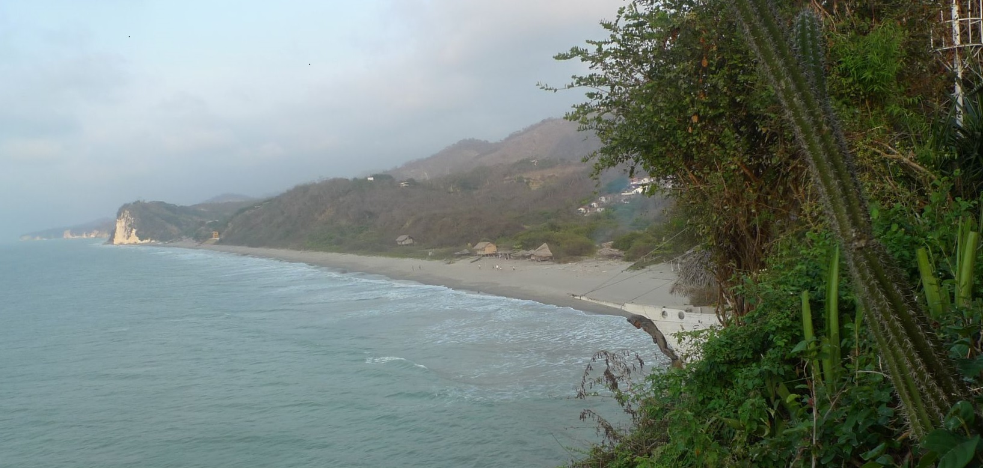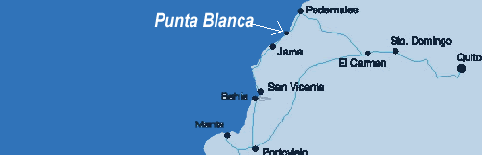
Accommodations options will be available soon. Informacion de acomodaciones estaran disponibles pronto.

[Address informatioN]
From $30 per person and up per night, depends on each hotel/cabanas. Acomodaciones de $30 en adelante depende hotel/cabanas.
Camping for free on the beach. (Need to bring your own gear). Campamento en la playa gratis, traer su propio equipo de campamento.
Thank you for joining this life changing experience!
Gracias por ser parte de esta experiencia inolvidable!

